**GHULAM ISHAQ KHAN INSTITUTE OF ENGINEERING SCIENCES AND TECHNOLOGY, SWABI, KPK**



**SEMESTER PROJECT**

**Project Name: Employee Management System**

**Subject: CS232(DBMS)**

**Sec: Data Science**

**Report by:**

**Muhammad Hamza Motiwala**

**2022380**

**Ahmed Bilal**

**2022064**

**Introduction:**

In today’s dynamic business landscape, efficient management of employee information is paramount for organizational success. Our Employee Management System (EMS) bridges the gap between data management and user-friendly interface, providing a comprehensive solution for HR departments to streamline their operations.

**Project Milestones:**

1. **Business Scenario Analysis:**

* **Business Need:**

The business requires an efficient system to manage employee information, including personal details, salary, and contact information. This system should facilitate easy addition, viewing, updating, and removal of employee records.

**2. Backend Infrastructure:**

At the core of our system lies a robust MySQL database, meticulously designed to handle the complexities of employee data management. Utilizing SQL queries, we have constructed a database named "employeemanagementsystem" with tables structured to store essential employee information.

The "login" table facilitates secure access to the system, ensuring only authorized personnel can interact with the database. Meanwhile, the "employee" table serves as the repository for vital employee details such as name, contact information, salary, and professional qualifications. Each entry is uniquely identified by an employee ID, allowing for swift retrieval and manipulation of records.

**3. Frontend Interface:**

Complementing our powerful backend infrastructure is an intuitive frontend interface developed in Java. The main screen of our application welcomes users with a visually appealing layout, featuring prominent options to add, view, update, or remove employee records.

Through seamless integration of backend functionality with frontend usability, our system empowers HR administrators to effortlessly navigate through the myriad tasks associated with employee management. Whether it's onboarding new hires, updating existing information, or conducting performance evaluations, our EMS provides a centralized platform for efficient data handling.

**4. ER Diagram:**

* **Entities:**

Two main entities identified are:

* + - Login: Stores login credentials for system access.
    - Employee: Stores detailed information about each employee.
* **Relationships:**

A one-to-many relationship exists between Login and Employee entities, as one login can be associated with multiple employee records.

* **Attributes**:
  + - Login: username, password
    - Employee: name, fname (father's name), dob (date of birth), salary, address, phone, email, education, designation, CNIC (national identification number), empId (employee ID)

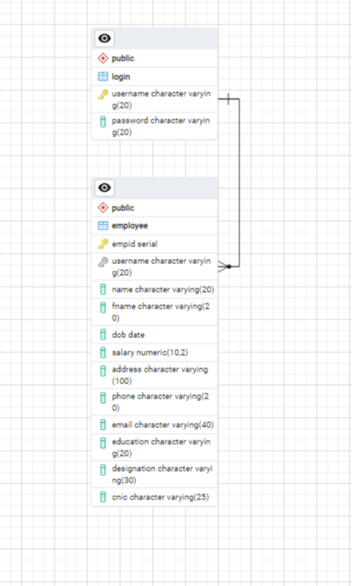

**5. Data Population:**

* DataBase:

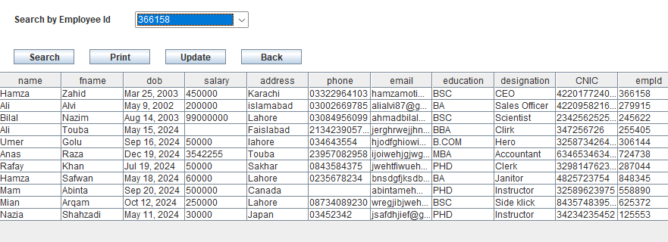

1. **Querying and Reporting:**

* **Queries:**

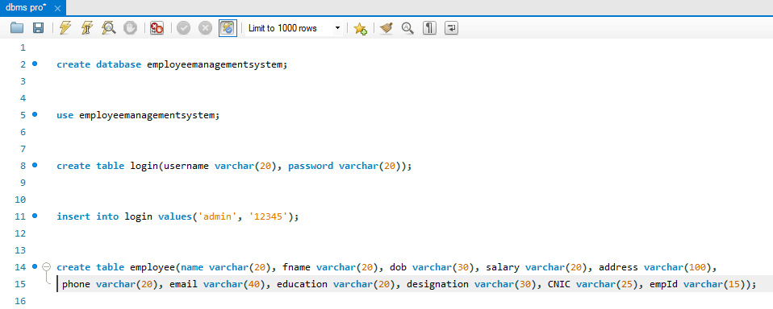

* **Report:**

This report presents a list of employees along with their basic information such as name, father's name, date of birth, salary, address, phone number, email, education qualification, designation, national identification number (CNIC), and employee ID. It provides a snapshot of the employees registered in the system, facilitating easy reference and management of employee data.

1. **User Interface:**

* Main Page:

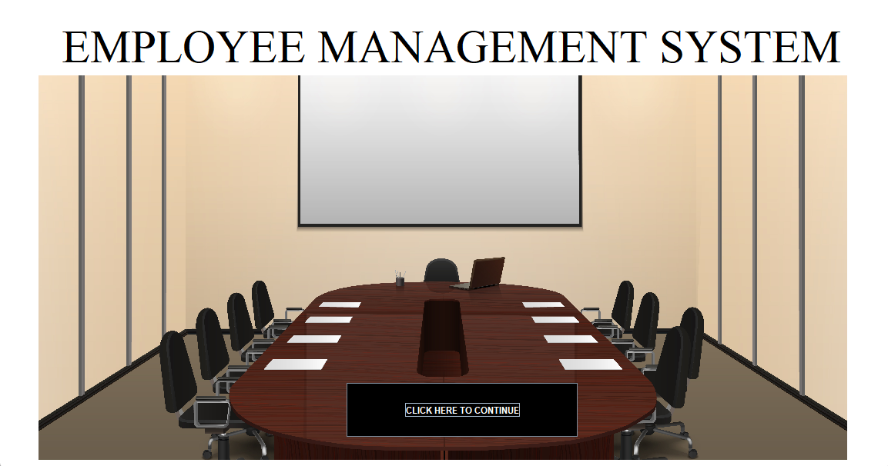

* Super User (Admin) Interface:

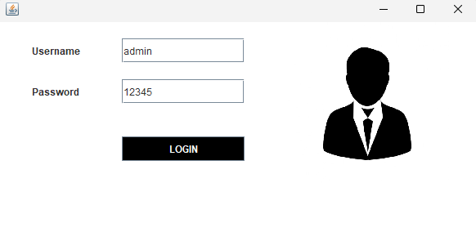

* Home Interface: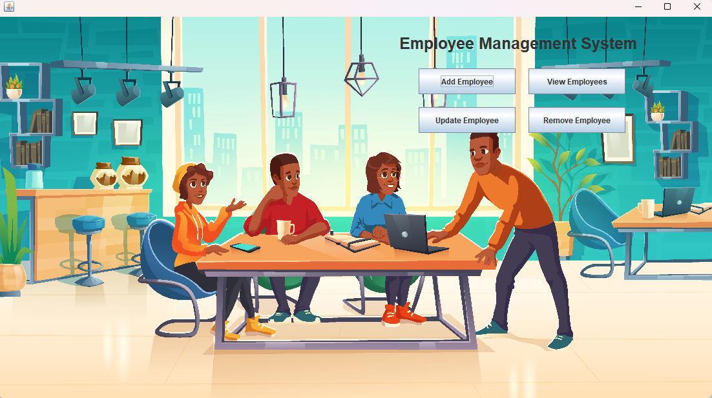
* Add Employee Menu:

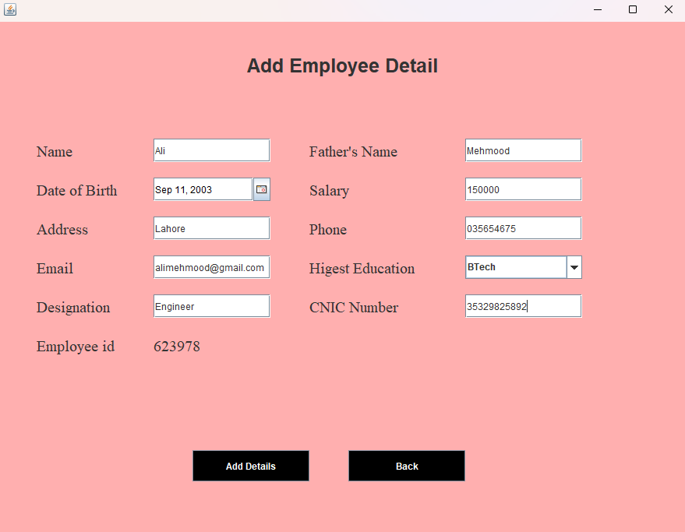

* View and Update Menu:

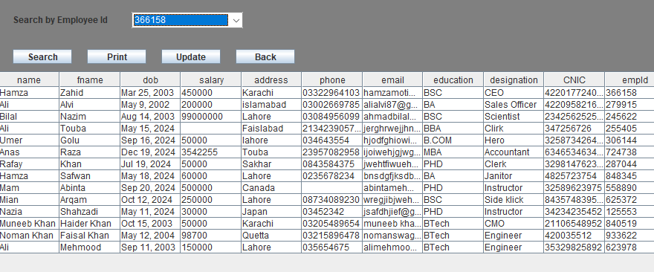

* Remove Employee Menu:

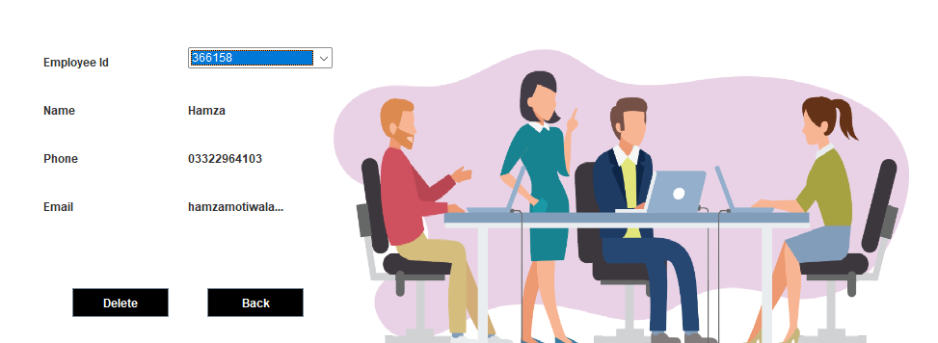

1. **Conclusion:**

In conclusion, our Employee Management System represents a culmination of database management principles and user-centric design, aimed at optimizing HR processes and enhancing organizational productivity. By leveraging the synergy between backend database operations and frontend user interaction, we present a comprehensive solution poised to meet the evolving needs of modern enterprises.